Opening using gedit:

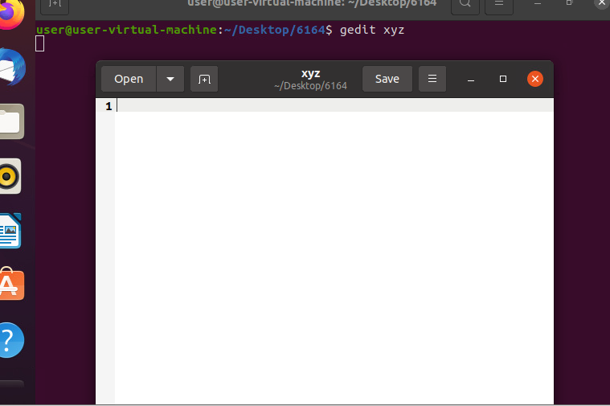

Vim command :

To vim editor:

1) Vim file name –enter

2) press ‘i’

3) escape to save the file and type ‘:w’ -- enter

4) to exit editor ‘:q!’-- enter

